+ current work

+ search with similarity

+ scale with 10^5 and 10^9 images

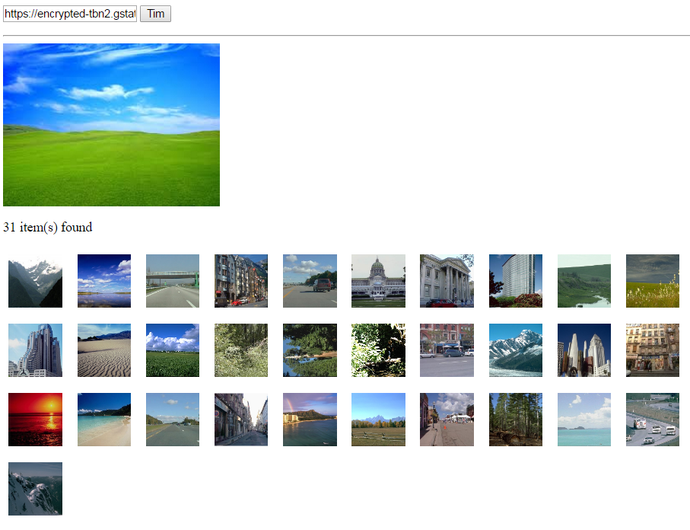

### We can search for similar color

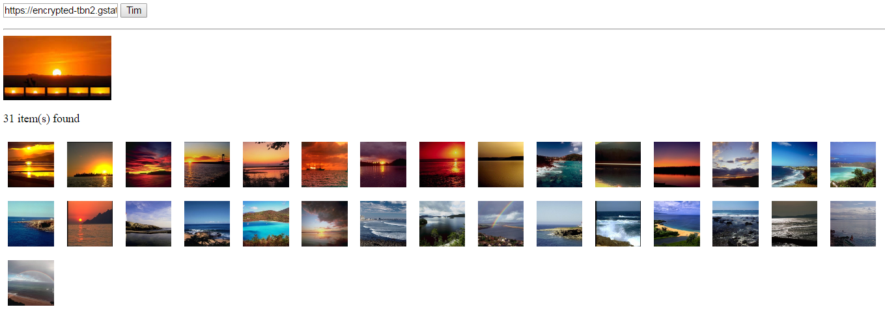

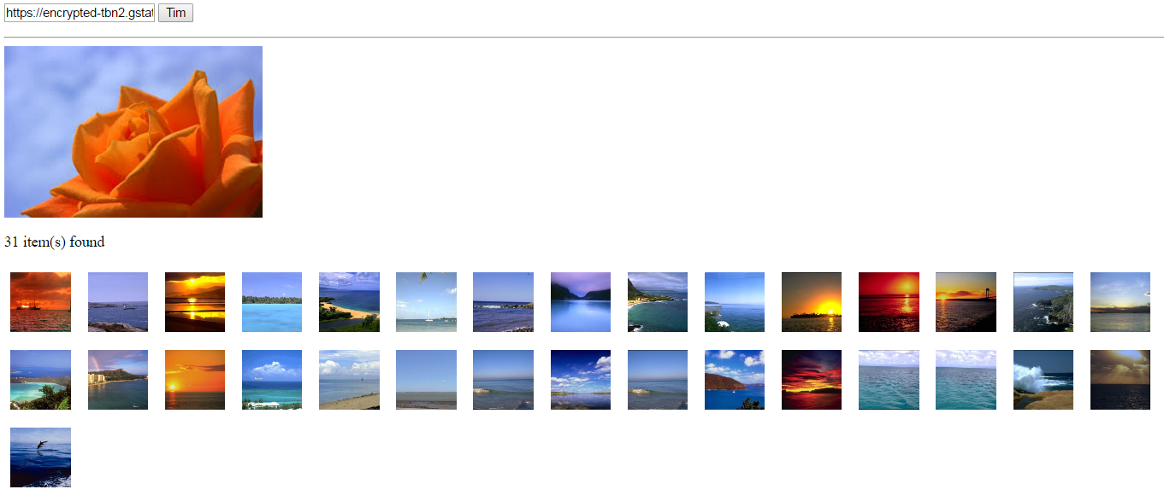

### Scalable search

+ index all the images with color

Red -> img1, img2

Green -> img3, img5

+ if we have a query image

Q -> { col1, col2 } -> imset(col1) + imset(col2)

10^9 images, but only 10^3 images with red color (we have to scan only 10^3) and another 10^3 images with blue

The query image has blue and red, we only have to scan 2*10^3

### Testing

<http://localhost:8080/nebula-rc2/index.jsp?q=https%3A%2F%2Fencrypted-tbn2.gstatic.com%2Fimages%3Fq%3Dtbn%3AANd9GcSeHsoqUB7nQESlPg2gnUb9rP9jrjVV2ubB8LR4deWxk-sX2ZWa>

<http://localhost:8080/nebula-rc2/index.jsp?q=https%3A%2F%2Fencrypted-tbn3.gstatic.com%2Fimages%3Fq%3Dtbn%3AANd9GcTb77xwA6RZXuqfu03ZN-gQgVE6J56zSbW6JhlOOFMNNup-Um5GY2UXRJG3>

<http://localhost:8080/nebula-rc2/index.jsp?q=https%3A%2F%2Fencrypted-tbn1.gstatic.com%2Fimages%3Fq%3Dtbn%3AANd9GcTg07pY1LruGrYbzks1F_1QhKfk4pWiY_MtJqu6O0Gm1tduxFRE>